Copyright reserved

Please turn over



**NATIONAL CERTIFICATE**

**STRENGTH OF MATERIALS AND STRUCTURES N5**

**APRIL 2018**

**13**

**This marking guideline consists of 7 pages.**

**MARKING GUIDELINE**

# QUESTION 1

✓

1.1 1.1.1 *FLOP* 72000 ✓

σ*LOP* = = −4 = 229,183*MPa*

*Ai* 3,1416 10×

1.1.2 σ*LOP*  *Li*  ✓ 6  0,085  ✓

*E* = *E* =σ*LOP* × *X LOP* = 229,183×10 .110×10−6 =177,096*GPa*

*LOP*

1.1.3 *FY* 90000 ✓ ✓

σ*Y* = = −4 = 286,478*MPa*

*Ai* 3,1416 10×

1.1.4 *FMax* 145000 ✓ ✓

σ*Max* = = −4 = 461,548*MPa*

*Ai* 3,1416×10

1.1.5 *FF* 80000 ✓ ✓

σ*F* = = −5 =1377,221*MPa*

*AF* 5,8088 10×

1.1.6 *X F* 21 ✓ ✓

%*X* = = ( ).100 = 24,71% *Li* 85

1.1.7 *Ai* − *AF* 3,1416×10−4 − 5.8088×10−5 ✓ ✓

%∆ =*A* = ( ).100 = 81,51%

−4 *Ai* 3,1416×10

(7 × 2) (14)

1.2

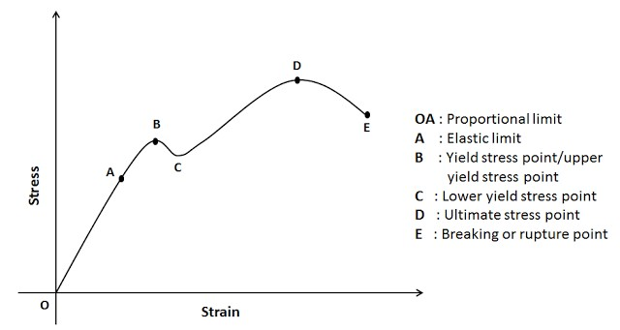

✓

✓

✓

✓

✓

✓

[Image source: [*http://www.mechanicalbooster.com/2016/09/stress-strain-curve-relationship-*](http://www.mechanicalbooster.com/2016/09/stress-strain-curve-relationship-diagram-explanation.html)

[*diagram-explanation.html*]](http://www.mechanicalbooster.com/2016/09/stress-strain-curve-relationship-diagram-explanation.html) (6)

# [20] QUESTION 2

2.1 2.1.1 *Fcau*sin *g* = *P D Li* . *i* .

=1,2 10 .(1,2).(2,× 6 5) ✓

= 3 600 *kN* ✓

2.1.2 *Fresisting* =σ*T* .2. .*t L*

= 72 10× 6.(2).(0,010).(2,5) ✓

= 3 600 *kN* ✓

2.1.3 π 2

*Fcau*sin *g* =*Pi*. .*Di*

4

=1,2 10 .(× 6 ).(1,2 )2 ✓

=1357,168 *kN* ✓

2.1.4 *Fresistnig* =σπ*L*. .*D ti* .

= 36 10 .( ).(1,2).(0,010)× 6 π ✓

=1357,168 *kN* ✓

(4 × 2) (8)

2.2 ✓

Fcirc. (resisting) Flong. (resisting *√*✓

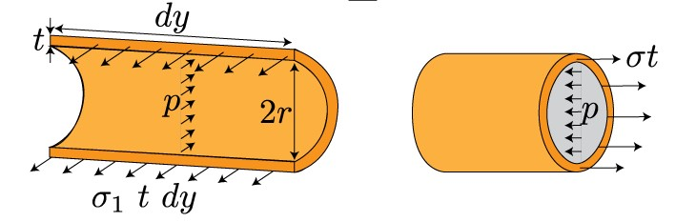

✓

✓

F

circ. (acting)

F

long. (acting)

[Image source: [http://www.bu.edu/moss/mechanics-of-materials-combined-loading/]](http://www.bu.edu/moss/mechanics-of-materials-combined-loading/) (4)

**[12]**

# QUESTION 3

3.1 π 4 π 4 −7 4 ✓

*J*1 = .*D* = .(0,048 ) = 5,2115 10× *m*

32 32

*T L*1. 1 = *T L*2. 2 ✓

*J G*1. 1 *J G*2. 2

✓

−7 = *T L*.

*TL*

.

3

1

2

1

2

1

✓

5,2115 10 .(2,2.× *G*2 ) *J G*2. 2

∴ =*J* 2 3,4396 10× −6 *m*4 ✓

*J* 2 = 3,4396 10× −6 =.[*D*4 − (0,048 )]4 ✓

∴ =*D* 79,697 *mm*✓ (7)

3.2 *TT* = +*T*1 *T*2 ✓

π 3 π (*D*4 −*d* 4 )

= . .τ1 *D* + .τ2.[ ]

16 16 *D*

π 6 3 ✓ π 6 (0,07974 − 0,048 )4 ✓ = .(84 10 ).(0,048 )× + .(46 10 ).[× ]

16 16 0,0797

=1824,034 + 3970,474

= 5794,508 *N m*. ✓  (4)

3.3 *N*

*P*= 2 .π .*T*

60

= 2 .π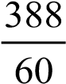.(5794,5087) ✓

= 235,438 *kW* ✓ (2)

# [13] QUESTION 4

4.1 *L*Re*action* .(7) = 2.(2).(7) + 4.(5) +1,5.(2).(3) + 7.(2) ✓

∴*L*Re*action* =10,143*kN*✓

1 1

*R*Re*action* .(7) + 2.(1).(2) = 7.(5) + 3.(4) + 4.(2) + 2.(1).(2) ✓

∴*R*Re*action* = 7,857*kN*✓

*PROOF* :2.(2) + + +4 7 1,5.(2) =10,143 + 7,857

18*kN* =18*kN* →*OK* ✓

(5)

.

4.2

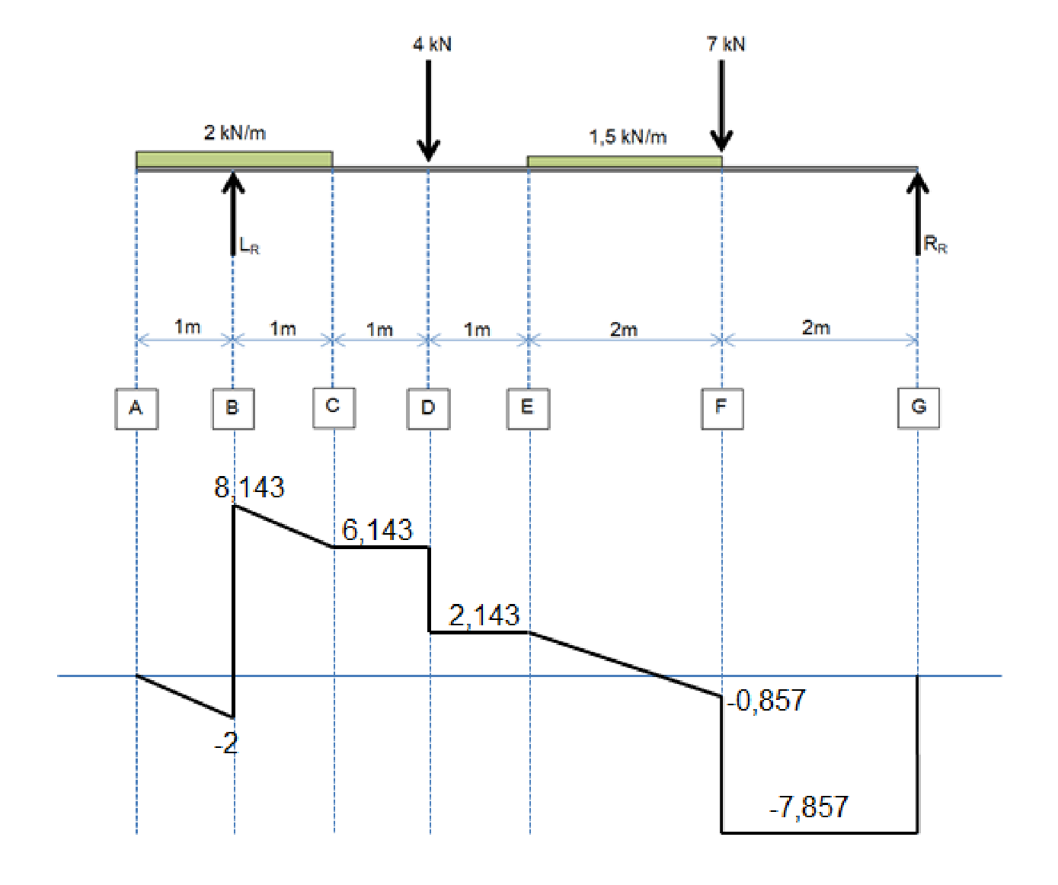

✓

✓

✓

✓

✓

✓

(6)

4.3 *TP*1 =1*m* From LHS √

*X*1 2 −*X*1 ✓

*TP*2 : =

*Y*1 *Y*2

*X*1 2 −*X*1

= ………………………………………………………….

2,143 0,857

0,857.*X*1 = 2,143.(2 −*X*1 ) ✓

∴ =*X*1 1,429 *m* ✓

*TP*2 = 2,5713 *m* From RHS √ (4)

4.4 *BM A* = 0

*BM B* =−2.(1).() =−1*kN*.*m*✓

*BM C* =−2.(2).() +10,143.(1) = 6,143 *kN*.*m*✓

 *BM D* =−2.(2).(+ +1) 10,143.(2) =12,286 *kN*.*m*✓

*BM E* = 7,857.(4) − 7.(2) −1,5.(2).() =14,429*kN*.*m*✓

*BM F* = 7,857.(2) =15,714 *kN*.*m*✓

*BM G* = 0 (5)

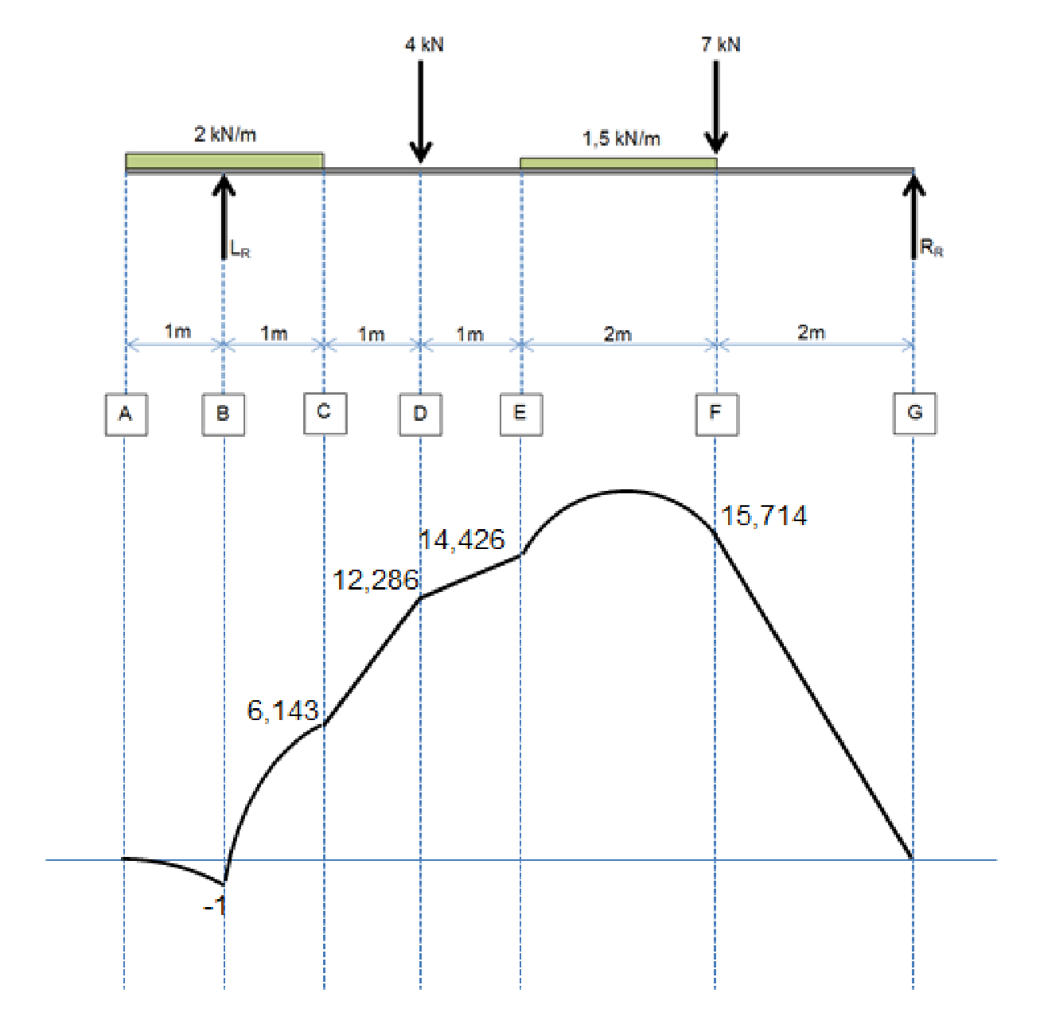

(5

)

*x*

✓

✓

✓

✓

✓

✓

4.5

4.6

0 =−2.( ).(*x* ) +10,143.(*x*−1)

2

✓

− +*x*2 10,143.*x*−10,143 = 0

−10,143± (10,143 )2 − − −4.( 1).( 10,143) ✓

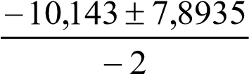 *x*= 2.( 1)− ✓

=

=1,12475*or* 9,01825

=1,125 *m*✓ (5)

**[30]**

# QUESTION 5

5.1 20sin 45 = 20cos 45 =14,142*N*

30sin 45 = 30cos 45 = 21,213*N*

*DEvertical*.(8) = 30.(6) + 21,213.(4) +14,142.(2)

∴*DE*= 36,642*N*✓ (1)

5.2 *FH horizontal* =14,142 +14,142 + 21,213 = 49,497*N* ✓

*FHvertical* = 21,213+14,142 +14,142 + −30 36,642 = 42,855✓

5.3

|  |  |  |
| --- | --- | --- |
| **Member** | **Force (N)** | **Nature** |
| eg | 75✓ | Tie (T)✓ |
| hi | 21,5✓ | Strut (S)✓ |
| ij | 47✓ | T✓ |
| kl | 0✓ | None✓ |
| dl | 62✓ | S✓ |
| jc | 70✓ | T✓ |
| bi | 49✓ | S✓ |

(21) **[25]**

*N*

*FH*

49,497

42,855

65,471

2

2

+

=

=

(3

)

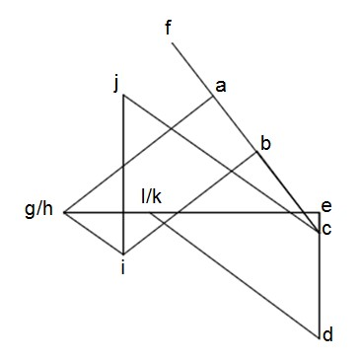

✓

✓

✓

✓

✓

✓

✓

✓

# TOTAL: 100